**Web-page Recommendation based on Web Usage and Domain Knowledge**

**Abstract**

Web-page recommendation plays an important role in intelligent Web systems. Useful knowledge discovery from Web usage data and satisfactory knowledge representation for effective Web-page recommendations are crucial and challenging. This Project we proposes a novel method to efficiently provide better Web-page recommendation through semantic-enhancement by integrating the domain and Web usage knowledge of a website.

Web-Page recommendation has become increasingly popular, and is shown as links to related stories, related books, or most viewed pages at websites. When a user browses a website, a sequence of visited Web-pages during a session (the period from starting, to existing the browser by the user) can be generated. This sequence is organized into a Web session .The objective of a Web-page recommender system is to effectively predict the Web-page or pages that will be visited from a given Web-page of a website

**Architecture**

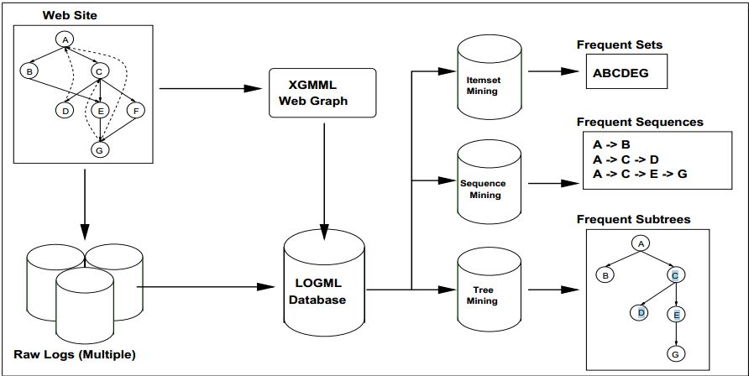

Fig -1 Web Usage Mining Architecture

**Existing system**

In the Existing system of this project there is no web-page recommendation method is available so it is not possible to give support to user by showing links related to stories, related books or most visited pages at the websites so Every time the user need to search about the content and get results it may not related to his search content. This is the drawback of existing system

**Proposed system**

All the drawbacks of Existing system are overcome by using proposed system of this project. In this we propose two new to represent the domain knowledge and give web page recommendation to the user.

1. The first model uses ontology to represent the domain knowledge.
2. The second model uses one automatically generated semantic network to represent domain terms, Web-pages and the relations between them.

Another new model, the conceptual prediction model, is proposed to automatically generate a semantic network of the semantic Web usage knowledge, which is the integration of domain knowledge and Web usage knowledge. A number of effective queries have been developed to query about these knowledge bases. Based on these queries, a set of recommendation strategies have been proposed to generate Web-page candidates. The recommendation results have been compared with the results obtained from an advanced existing Web Usage Mining (WUM) method.

**Techniques used**

We classify the research work related to Web-page recommendation into the following two categories

1. Traditional approaches that use sequence learning models
2. Semantic-enhanced approaches

**Traditional approaches that use sequence learning models**

In applying sequence learning models to Web-page recommendation, association rules and probabilistic models have been commonly used. Some models, such as sequential modeling, have shown their significant effectiveness in recommendation generation .In order to model the transitions between different Web-pages in Web sessions. Pre-Order Linked WAP-Tree Mining (PLWAP-Mine for short), is outstanding in supporting Web-page recommendation, compared with other sequence mining algorithms.

**Semantic-enhanced approaches**

The semantic-enhanced approaches integrate semantic information into Web-page recommendation models. By making use of the ontology of websites, Web-page recommendation can be enriched and improved significantly in the systems in the systems, domain ontology is often useful for clustering documents, classifying pages or searching subjects. Domain ontology can be obtained by manual or automatic construction approaches

**System Requirements**

**Hardware Requirements**

Processor : Pentium IV

RAM : 128 MB

Hard disk : 80 GB

Monitor : 14 inch

Mouse : 3 Button scroll

Keyboard : 108 keys

**Software Requirements**

FRONT END : ASP.NET

LANGUAGE : C-Sharp

BACK END : SQL Server 2008

OPERATING SYSTEM : WINDOWS XP